STAGE CREW HANDBOOK
2019-20 School Year

CHARLOTTE PERFORMING ARTS CENTER
378 State Street
Charlotte, Michigan 48813
www.charlotteperformingartscenter.com

Contact Information

Hollie Auten Facility Supervisor 517-541-5691 autenh@charlottenet.org

Amy Jo Parish
Technical Supervisor
517-541-5698
parisha@charlottenet.org

Box Office
517-541-5690
Welcome!

Thank you for your interest in joining Charlotte Performing Arts Stage Crew for the 2019-20 school year. There are many exciting performances in this season’s line-up, and your technical assistance is appreciated and essential to their success.
The Stage Crew at Charlotte High School works to ensure the smooth operation of the Charlotte Performing Arts Center for every event. We work with administration, school clubs, and professional groups to provide technical support in stage management, fly rail, lighting and sound, along with the setup and strike of the events.
There is a variety of equipment and systems within the Charlotte Performing Arts Center that you will become familiar with over the coming months. This handbook has been created to allow you understand your position as a member of Stage Crew and what will be expected from you. Although there are many regulations and rules, please remember that they are not in place to hinder you from having fun, but to make sure you stay safe while doing so.
We look forward to working with you! If you have any questions regarding the policies or information stated in this handbook, please do not hesitate to contact Amy Jo Parish, Technical Director or Hollie Auten, Facility Director.

Sincerely,

Amy Jo Parish Hollie Auten
Technical Director Facility Director
517-541-5698 517-541-5691
parisha@charlottenet.org autenh@charlottenet.org

MEMBERSHIP:
Membership into Stage Crew is open to all students in grades 9-12. Students are allowed to join Stage Crew at the beginning of the school year and at the start of second semester at the discretion of the F.D. / T.D. Members must obtain an average or better academic grades to participate. Above all, your schoolwork comes first. Students with more than two failing grades will not be permitted to join CPAC Stage Crew. Grades will be reviewed at the beginning of each semester by the T.D.

Crew meetings will take place the last Wednesday of each month, in the drama classroom. During the meetings, you will also be able to sign up for crew calls for the coming month.

Workshops/shop hours will be held typically on Wednesdays after school. These workshops will run for an hour after school, and each Stage Crew member is expected to attend, unless excused by the T.D. / F.D. During the workshop, you will gain hands-on experience on different technical topics, and partake in team-building exercises with your colleagues

ALL COMMUNICATION ABOUT WORKSHOPS/SHOP HOURS/TRAINING, ETC. WILL BE POSTED TO THE STAGE CREW FACEBOOK PAGE AND THE BULLETIN BOARD BY THE SCENE SHOP.

TRAININGS:
Trainings will be scheduled to provide Stage Crew members with the knowledge and skills needed to operate the equipment within the Performing Arts Center:

Basic Safety Training – REQUIRED FOR ALL STUDENTS.
*Rigging/Scene Shop Training – This training is in conjunction with Basic Safety Training. Learn about our fly system, how to hang and fly things above the stage and scenery construction.
At the conclusion of each training, students will be given a short quiz to test their ability to perform the tasks. After successful completion of the quiz, the member will be certified and able to participate on crew calls and work events in the area of certification.
Students must make every effort to attend the scheduled trainings. However, if circumstances make it impossible to attend, trainings may be rescheduled at the T.D/F.D.’s discretion.

Audio Training - Learn how to operate our sound system: set-up, patch, and operate microphones and monitor speakers.

Lighting Training - Learn how to operate our light board, gain knowledge on the different types of lights and their functions, gel, and tour our catwalks and spot booth.

PAID STAGE CREW POSITIONS:
Interested in a little extra pocket money? Become a student staff member for professional and rental events! In order to be eligible to work paid stage crew positions, students must complete trainings in addition to 100 volunteer hours.

Here’s the breakdown:
Audio Training
Complete training in addition to 40 hours (30 hours working audio for events and 10 hours assisting in other audio setup/projects).

Lighting Training
Complete training in addition to 40 hours (30 hours working lighting for events and 10 hours assisting in other lighting setup/projects).

Basic Safety/Rigging/Scenic Construction Training
Complete training and 20 hours assisting with rigging or scenic construction or installation.

If you have completed the allotted 100 volunteer hours and have been approved to be a member of student staff, you will receive pay of minimum wage per hour for all hours worked on eligible events (rentals and professional/touring events).

STAGE CREW POLICY:

- You must fill out and sign a crew application each year to continue to be part of Stage Crew. The application must also be signed by a parent or guardian.
- You must be punctual for all crew calls and events to which you are assigned. Failure to do so will affect eligibility. If you will be running late or unable to make the crew call, please contact the T.D. / F.D. as soon as possible.
- You are responsible for your own transportation to and from work calls and events.
- It is your responsibility to check schedules and call times to assure you are on time for all events you are working.
- If you are unable to work an event you have signed up for, you must notify the Facility Director or Technical Director AS SOON AS POSSIBLE. You are responsible for finding a suitable, properly trained replacement. Failure to give proper notice or find suitable replacement may affect eligibility. If you are ill and out of school, notice must be given to the F.D./T.D. along with the school. The high school office is not aware of any crew calls/rehearsals/performances the student is scheduled to work so separate notice must be given to the T.D./F.D. While school and family business are important, members who continually do not show for scheduled work calls or events will be removed from the crew roster.

CELL PHONE POLICY:
A student stepping out to take a cell phone call during a crew call, rehearsal or performance can disrupt the entire event. Students with cell phones should turn them to the silent or vibrate mode and not answer calls / text messages while working. Please refer to and adhere to the guidelines included in the Charlotte Public Schools Student Handbook.

CREW CALLS:
Event sign-up sheets will be distributed at each Stage Crew meeting, normally held the first Tuesday of each month. Sign up for as many positions as you like. Some positions require specific certification and/or experience; these will be indicated on the sign-up list.

For each position there are multiple lines for signup.
- Some positions, like lighting crew, require more than one person, the T.D. will select who is assigned to the crew.
- Other positions, like board operator, require one person. If more than one person signs up for the position, the T.D. will decide who will work.
If you would like to be considered for a paid crew call (and are eligible), you also need to sign up for at least one unpaid crew position per every two paid events.

BEFORE you sign up to work:
- Make sure you are available on the day and time listed.
- Do not sign up unless you are absolutely sure you can work.
- Make sure you are certified to work the position; stagehand positions do not require previous experience, but do require that you have a basic knowledge of the theatre.

The confirmed crew call assignment list will be posted next to the Stage Crew bulletin board within 24 hours of the meeting. The Stage Crew bulletin board is located on the wall in the hallway between the drama room and scene shop.
The assignment list must be checked within three days from the Stage Crew meeting to see which, if any, of the crew calls you have been selected for. Students must initial next to his or her name to indicate that they accept the position. If you do not initial next to your name within three days, you will be replaced on the crew call.

Please take a copy of the crew call assignment sheet when you initial next to your name. This is to help you remember which event(s) you will be working and what time you will need to show for the crew call.

STAGE CREW ETIQUETTE:
Arrive early enough to sign-in with T.D. / F.D. before your designated crew call time.
- Arriving late will impact future crew assignments.
- Make sure you know which position you have been assigned.

*Do not work outside your designated area unless approved by the T.D. or F.D.
*No food or drink (water bottles with a closed cap acceptable) in the control booth.
Please pay close attention when given instructions by your supervisor or touring personnel. If you do not understand any portion of the instructions you were given, PLEASE ask for clarification from the person who gave you the instructions. It will take less time to clarify the instructions then it would for you to do the task and then you or someone else redo the task.
You must reply to questions or instructions given by tour personnel. Make sure you reply in a loud enough voice so that the person asking the question or giving instructions hears you.

DRESS CODE FOR CREW CALLS:
The following dress code must be adhered to whenever you work an event, regardless of your position (backstage, light/sound, etc.):
- Black Stage Crew Shirt (provided like a uniform – you will be responsible for the care of and will return the shirt at the end of each year)
- Black Pants
- Black Shoes and Socks

There will not be any exceptions given to the dress code. If you do not have any of the above items, you need to get them. Failure to follow the dress code may result in being cut from the show crew and could impact your eligibility to work future paid events.

CHAPTER ONE: SAFETY FIRST!
Safety is first priority before any activity takes place in the scene shop or auditorium. Please remember that the aim of these guidelines is not to stop you from having fun, but simply to ensure it is done in a safe manner.
IF IN DOUBT – PLEASE ASK BEFORE YOU ATTEMPT!
Never guess with backstage work - it can be fatal.
From circular saws to high voltage, backstage can be a dangerous place if equipment and systems are not used properly. If you are not sure how something should be done, please ask a knowledgeable adult! You are responsible for your own safety and the safety of people around you. Anyone deliberately or repeatedly ignoring safety guidelines will be removed from Stage Crew.

Alcohol and Drugs
No Stage Crew member is to use illegal drugs or alcohol during an event, either during load-in, during the performance, during the load-out or be under the influence while working an event. Any Stage Crew member doing so shall be asked to leave. Any member who needs to take medication should be sure they are fully aware of the effects it produces and should not undertake duties which are against the guidelines on the medication. Please refer to the medication section of the Charlotte High School Handbook for additional information.

First Aid

First aid kits are located in the scene shop, box office and in the House Left Vestibule. The first step after any type of injury is to immediately notify your supervisor. Your supervisor knows the next steps that need to be taken. Do not attempt to treat an injury on you own – notify your supervisor immediately! If for some reason, your supervisor is not immediately available and the injury requires it, call 9-1-1.

Medical Conditions
Any Stage Crew member suffering from a medical condition that could affect their ability to work a crew call or event should inform the facility director/technical director in confidence. They will then ensure that the member is not asked to do something unsuitable and that they are given warning of anything which might aggravate their condition, e.g. a clear warning must always be given before the use of strobes.

If a member has any special requirements (e.g. dietary) then they should inform the T.D. / F.D. in writing, preferably by e-mail, to ensure that the event manager remembers to make the necessary arrangements.
Any member taking medicines should follow the manufacturer's recommendations for the use of the drug and common sense (e.g. those taking strong pain killers should not continue with Stage Crew work). Please refer to the medication section of the Charlotte High School Handbook for additional information.

Electrical Safety
Almost all of our events involve large amounts of electricity, and even the smallest amount used in the wrong way can have disastrous consequences. Accordingly, electricity must be dealt with carefully. The best way to ensure electrical safety is to prevent faults from developing by regular maintenance of equipment and ensuring that the distribution is in the hands of an experienced individual.
The ground rules for electrical work on events are as follows:
- Be on the lookout and take care when working with frayed wires, loose wires, loose fitting wires, etc.
- Be certain there is no power running to a piece of equipment you are working on.
- Be on the alert for warm wires, they might indicate an electrical problem. Notify your supervisor if you encounter one.
Theatre fixtures cannot be plugged in anywhere, the outlet may already be fully loaded, or it may require special power supplies. As a general rule: Most dimmers are rated at 20A - this is about 2400 watts of light.
- Firmly tape down all cables, especially if they are across doorways or across other traffic areas.
- Uncoil cables completely before using - running current through a coil of cable generates heat, on a large drum this can be enough to cause a fire.
Don’t attempt to repair electrical cables, lighting or special affects equipment without the permission of the T.D. or F.D.

Repair and Maintenance
Any items that require repair should be brought to the attention of the T.D. / F.D., so that they can either repair it or remove it from service. If the T.D. and F.D. are not available then the item should be removed from service until repairs can be completed.

Scene Shop and Tool Use
The scene shop is where our carpentry and metalwork is done. It contains an assortment of hand and power tools. You shouldn’t be in the workshop alone, another person should be present to summon help in case of an accident.
Only use tools which you are familiar with, the T.D. and/or experienced adults are there to provide you with training to use the tools we own. The better the tools are treated, the longer they last and the more we can buy, so please take care of them. Any tools which you bring in must be approved by the T.D. Please do not use other members tools without their permission and unless you are familiar with them.

Manual Handling
While it might sound patronizing to tell you how to lift objects, it is an important subject, especially since it is easy to get wrong. We lift heavy objects fairly frequently and to minimize the risk of injury it is important to do it right.
- Always plan a lift:
  - Think about what you are lifting - how many people are required to control it?
  - Make sure everybody knows where you are carrying the object to.
  - Consider any aids which could reduce the effort required - could you lift the object onto a wheel board instead of carrying it the full distance?
- Lift together when everybody is prepared and on a count.
- Lift with your legs. Your back should remain straight at all times. When lifting properly, you should: squat down and get a grip of the object, then rise to your feet holding the object.
- Ensure you all put the object down together and with the same care that you lifted it.
Take care when lifting an object onto a wheeled surface - ensure that it can’t escape!
Working at Heights
No one is required to work at a height they are uncomfortable with, however, for those who are confident working at height there is plenty to do during the course of a show. If you are working at height you must take all care to avoid dropping things onto the people below, elementary precautions include; ensuring that you have nothing on you which might fall and hit somebody/thing and if you need to drop something announce clearly what you are dropping and where you are dropping it e.g. ‘Heads, upstage left, rope dropping in’.
Anyone working on the scissor lift must attach tools they are using to a safety cable to avoid injury to anyone working below.

Rigging
No one is permitted to operate the counterweight system until they have been trained and certified. Before any object is rigged the operation should be thought through and appropriate measures taken to ensure that the object is under full control at all times.

CHAPTER TWO: LIGHTING

BASIC LIGHTING TERMS
Barndoors: with a similar purpose to that of shutters (but used on Fresnels and PARs), these are attachable metal pieces that have hinged panels that can mask the light out of certain areas.

Color frame: two connected square pieces of metal or cardboard with a hollowed circle in the center; this frame holds the gel in front of the fixture.

Cyclorama: also known as cyc; a curved piece of cloth or wall that serves as a backdrop; may be painted scenery or plain in order to project light and/or images onto it.

Diffusion: similar to gel, these sheets are used to diffuse, or soften the beam of light and don't usually change the color of the light (unless it is colored diffusion).

Gel: also known as color media, filter; the plastic film placed in front of lights to change the color of the beam of light.

Intensity: the level of light output coming from the fixture (usually measured in percentages on a control board); the brightness of the light.

Lamps: light bulbs (the equipment they are used in are referred to as "fixtures").

Open-face fixture: any lighting fixture that has no lens.

Pattern holder: a rectangular, metal frame with a circular hole in the center. This piece holds a pattern and slides into a slot in an ellipsoidal fixture.

Patterns: also known as gobos; thin, steel, circular pieces with a design cut-out; when placed into a slot in the ellipsoidal, these project patterns of light onto the stage.

Shutters: a moveable piece within the ellipsoidal that can shut out part or all of the light coming out of a fixture.

Snoot: also known as top hat; an attachable accessory with a long cylindrical tube used to reduce flare (stray light beams) from lighting fixtures.

Types of Lighting Fixtures:

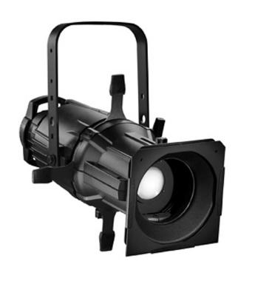 | ELLIPSOIDALS  This is the most common type of fixture used for accenting. Also called an ERS (Ellipsoidal Reflector Spotlight) or Leko® (which is a trademarked type of ellipsoidal created by Strand Lighting), the ellipsoidal can adjust from a sharp-edged, focused beam to a soft, diffused light. Using shutters, the beam can be shaped (for example, if part of the light "spills" off the stage into the orchestra pit, the shutters can be used to crop the beam so the pit is not lit). Ellipsoidals also have features to hold patterns and gel .
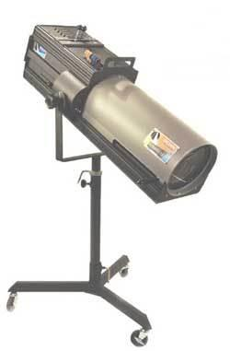 | FOLLOWSPOTS  This type of fixture you see all of the time in concerts, ice skating, lectures and other performances where the main character(s) moves around constantly and unpredictably. It is the type of fixture that is controlled by an operator standing beside it. Although different followspots sport different features, most will let you adjust the beam size, instantly change the color, and many will let you lock pan and tilt adjustment.
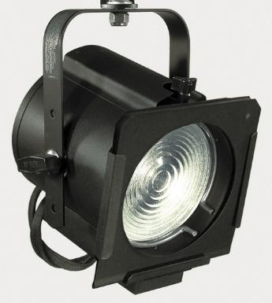 | FRESNELS  (Pronounced fra nel'; named after the inventor of the lens): This instrument is somewhat similar to the ellipsoidal, but has a softer edge to the light beam. The beam can go from narrow to wide, but shutters are not available on the fixture to shape the beam, nor is it able to utilize patterns. Fresnel spotlights are often used for near-stage are washes.
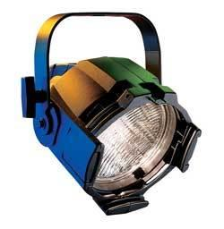 | PAR CANS  Depending on the brand/model of a PAR can, the beam of the fixture might be able to adjust from a horizontal to a vertical beam. The lens can be part of the lamp, so by changing the lamp type, you can change the beam angle.
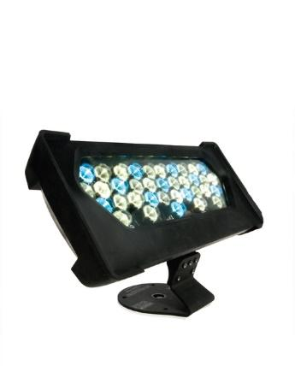 | FLOODLIGHTS  Also known as Scoop; Pretty much the same as a PAR can, the floodlight is less directional and will provide more of a wash than the PAR can fixture. Floodlights are relatively inexpensive, durable and lightweight. They cannot support patterns, beam adjustment or any other accessories except color and diffusion.
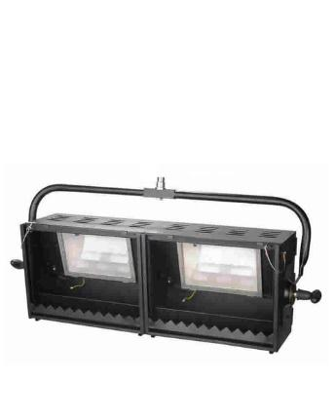 | CYC LIGHTS  Open-faced fixture which gives an even wash of light over a vertical surface (such as a cyclorama or painted scenic drop).
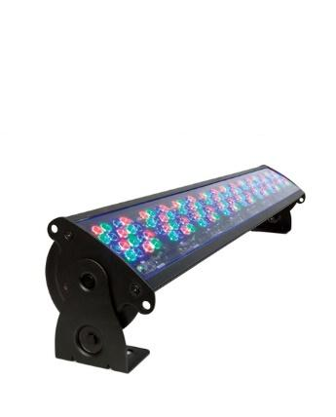 | STRIP LIGHTS  Also known as borderlight; A wash fixture similar to a cyc light; used to add color or general lighting on stage.
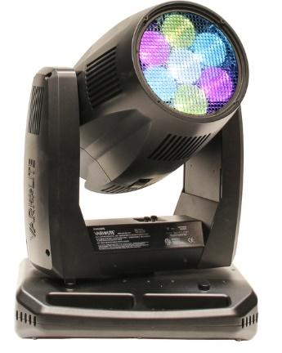 | LED LIGHTING  Also known as solid state lighting, LED fixtures typically include color changing capability and on board dimmers. LED models are available to replace most conventional lighting instruments.
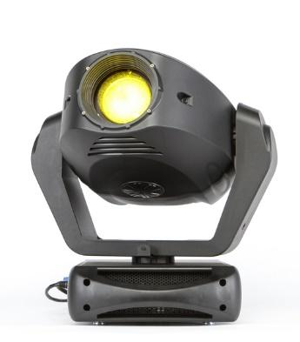 | AUTOMATED LIGHTING  Also known as intelligent lights or moving lights, automated luminaires usually combine high output arc lamps with numerous features. Moving light fixtures often include pan and tilt control as well as other controllable attributes such as focus control, shutters or irises, color changing / mixing devices and even strobe effects.

Parts of a Lighting Instrument:
This image of an ellipsoidal was taken from: https://en.wikipedia.org/wiki/Stage_lighting_instrument.
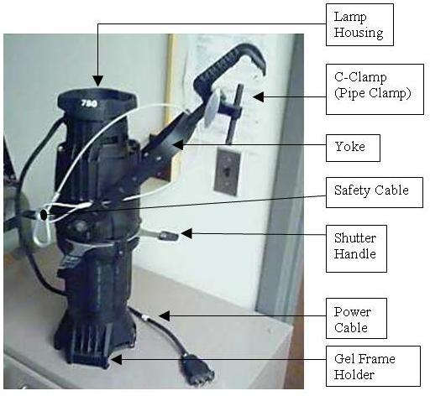

Important things to note:
  - When in the catwalks, make sure your wrench is tied securely to your person. If needed, take long tie line or a bungee cord and tie to wrench, then tie the remaining string to belt loop.
  - NEVER take hold of a lamp with bare hands, whether inserting or taking out of a fixture. Unit is very fragile and may be hot if used in working fixture. Use gloves or t-shirt when handling lamps.
  - When cutting gel, make sure to label appropriate color with white china marker VISIBLY in large print.
  - If a gel has holes or faded color (usually seen in the center), throw away.
  - ALWAYS clip safety cable to lighting fixture and around boom BEFORE you mess around with the fixture. We do not want the fixture to fall!
  - If you have questions or in doubt about something, ASK. Your T.D. / F.D. are here to help.

Lighting Inventory at CPAC:

8 Strand SL Series 50° Ellipsoidal Spotlight 575 watts
20 Stand SL Series 36° Ellipsoidal Spotlight 575 “
30 Stand SL Series 26° Ellipsoidal Spotlight 575 “
28 Stand SL Series 19° Ellipsoidal Spotlight 575 “
20 Altman 6" Fresnel 750 “
24 Altman StarPAR with Lens kit 575 “
7 Altman Ground Cyc triple cyc lights 1000
4 Altman Ground Cyc single flood light 1000
8 Altman Strip lights (4 color roundel: red, blue, green, amber) 1200 watts per color
2 Lycian #1209 Follow Spot (in Spot Booth, not removable)
4 Apollo SmartColor 7.5 Scrollers
6 Apollo SmartMove DMX Rotators
2 Gam Film/FX units

Lighting Control Console:
ETC Lighting Console
197 – 2,400 watt dimmers (for stage use)
19 – 2,400 watt dimmers (for house lights)
24 submasters

CHAPTER THREE: Audio
A bare-bones sound system consists of only a few main parts. You have a bunch of sound sources (microphones, CD players, etc.) fed into a mixing board (a device which combines a bunch of inputs into a couple of outputs). The “mixer” is fed into one or more amplifiers, which take the sound and gives it enough power to drive the speakers.

SPEAKERS:
Speakers are the last part of the sound system chain, and have a huge effect on the sound quality the audience hears. The speaker is more or less an electromagnet and one or more cones (the circle you think of when you think speaker... usually made out of cardboard, foam, or aluminum) inside a wooden “cabinet”. It's pretty important not to overdrive the speakers- i.e. try and turn them louder than they should go. The sound will be pretty distorted (imagine a classical guitar... and now imagine Nirvana. That's what distortion is. Sometimes you want it, but most of the time you don't). Even worse, you run the risk of “blowing” the speaker... when you turn it too loud or try and reproduce frequencies which are too low (turn up the bass), the speaker will try to move the cone farther than it's designed to go and end up ripping it. You can't fix the speaker when this happens usually, so you'll end up having to buy new ones.

AMPLIFIER:
The amplifier takes the sound you put into it, and makes it powerful enough to drive the speakers. You plug some sort of sound source (through a mixer or not) into the amplifier, and amplifies it.

MIXER BOARD:
The mixing board lets you take a bunch of sound sources and combine them into a smaller number of outputs. As an example, you might take 8 different microphones and then combine them into 2 outputs (a left and a right). The mixing board may seem intimidating- there are a lot of buttons- but there's a bunch of repetition, so it's actually not bad at all! \The main parts of a mixing board are a) a bunch of channels, b) a master output section, and c) Auxiliary Buses (on nicer boards).

Channels: Each board has a number of channels, usually in multiples of 8. A small board will have something like 8 channels, while large boards will have something ridiculous like 128! The number of channels you need is basically the number of sound sources you have. Each channel will usually have the following buttons/meters/plugs: (Start with them all turned down except for the EQ knobs in the middle)

- Inputs: On the back/top of each channel, you'll usually have a microphone input that is an XLR plug and a line level input that is a 1/4” plug. Generally, microphones should be plugged into the microphone input and everything else (i.e. CD players) should be plugged into the line input. Sometimes there'll be only one input and a button to choose whether its mic or line level, so use those same guidelines in selecting.
- GAIN - What the gain button does is control how much signal goes into that channel from the sound source. The general rule of thumb is to start off with the gain all the way down. Then either turn a CD on or start talking/singing into the microphone that's plugged into the channel. Somewhere on the channel, there are LED's- usually a green one that indicates signal and a red one that indicates clipping. Sometimes they're combined in one that is usually green and turns red when the signal is clipping. Slowly start turning the gain up. So what do you want? You want the signal to be green most of the time and occasionally flashing red. Turn up the gain 'til it does that.
- There should be a FADER FOR THE VOLUME. On cheaper mixers, sometimes you'll only have a knob. If you turn it up right now, you probably won't hear anything. That's because the master is down.
- [Not on smaller boards] Nicer boards generally also have a bunch of random buttons labeled “L-R” “1-2” “3-4”, etc. What these do is choose what outputs you're sending this signal to. So if you have a ton of different outputs and want to send the signal to all of them, make sure all the buttons are pressed. If you only want it to go to the master, choose “L-R”.
- [Not on smaller boards] You also might find a bunch of knobs labeled “1” “2” “3” “4”... sometimes with the words “Aux” in front of them. These choose how much of the signal to send to each Auxiliary Bus.
- Phantom Power/+48V. This button should be off except when you have a condenser microphone or another piece of audio equipment that explicitly asks for phantom power explicitly.
- The EQ section allows you to change the quality of the sound. You can add or subtract treble (high sounds), mids, or bass (low sounds). If the sound is kind of “muddy” or “undefined”, you generally want to add more treble and turn down the bass. If the sound is grating or kind of tinny, you want to add more bass or turn down the treble. A lot of boards have a variable mid so that you can fine-tune your sound. I like to leave them both in the middle first. Now, try and listen and figure out what you need more/less of in the mix. The variable mid has 2 knobs, one is called “level” and one is called “frequency”. Turn the “level” up a lot and move the frequency knob around slowly until you hear what you want to add more of. Basically, it'll sound ridiculous, but it'll let you hear what you're actually modifying at that frequency. Now, when you hear a sound that you want to raise/lower, leave the frequency there and turn the level to a point where it sounds good.
- The ON button turns the channel off. Not all boards have them. They're great when dealing with wireless microphones, though.
- The L/R Section - Here, you'll control the volume for the whole board. If the MASTER VOLUME is down, you won't hear anything.
- The Aux Buses (Submasters) - There are two good uses for them, generally- grouping together channels that you generally want to move together, and adding more outputs beyond what is contained in the master. First use- grouping channels together. Imagine mic-ing a drum with 5 different mics. In this case, don't “patch” the channel to the master (i.e. don’t press down the “L-R” buttons). Only patch them to an Aux Bus. Use each individual channel's volume fader to set the relative volumes. Now, you have to patch the Aux Bus to the master (choose it to output to “L-R”). So now if the drums are too loud, you just have to turn down the fader for that Aux Bus rather than for each mic. Second use- adding more channels. Aux buses will usually have an output (Aux 1 out, etc.). If you want surround sound speakers, or you want to have, say, a subwoofer, connect those speakers to the aux outputs. Now, everything you want to go through those speakers... patch those channels into the aux. \When connecting all of this, plug all of the sound sources to the board, then plug the outputs of the board into the amplifier and then into the speakers. Don't turn anything on yet and keep the volume all the way down! Turn on the board first. THEN turn on the amplifiers. (You don't want to amplify the noise of turning on a sound board... it'll mess up the speakers since there's a big pop). At the end of the night, turn off the amps first, then turn off and unplug everything else!

For stage, there are 4 main types of microphones you'll use:

- Border microphones are used at the edge of the stage/playing area to pick up the general sound. If you were doing a straight play in a large theater, you'd consider putting some mics on the edge of the stage. Look up border microphones on eBay or in a Border mics usually need phantom power.
- Choir microphones hang above the actors. These are actually best left to picking up choirs since they tend to feed back or randomly make actors near them really loud. Always make sure they're facing upstage (away from the audience) unless you really like feedback. These usually need phantom power.
- Dynamic microphones are what you normally think of when you hear the word microphone. If someone needs to walk up to a microphone and talk, use these. Don't use phantom power, you'll mess them up.
- Wireless lavalier microphones. These are what you usually see in musicals when you want to hear a singer above a really loud orchestra. In terms of where to put the microphone on a person, you've usually seen presenters at conferences and such clipping the wireless mics to their shirt collar. Never do that in the theater since you'll hear every time their shirt rustles, the mic will be far away from their mouth, it'll get in the way during costume changes, and any time they turn their head and talk, you won't hear them. As to the proper place to put a lavalier mic, there are 2 reasonable places: either sticking out of the hair or taped to the cheek. A lot of people prefer to have the cord come up the back of the actor's head, weave through their hair, and then magically pop out right above their forehead, sticking out about ½ to 3/4” of inch and pointing down towards their mouth. Bobby-pin the mic to the hair in a bunch of places. The advantage to this approach is that the mic is hidden pretty well, but the disadvantage is that it's pretty far from the person's mouth. I personally prefer to take the microphone to the cheek with clear medical tape. Of course, make sure the mic isn't right up against the cheek- it should crane out a fair bit so that it has direct line of sight with the actor's mouth. Clear medical tape is pretty invisible if a coat of makeup is applied over it. Now, the belt pack can either be clipped to the actor's pants or worn in a pack.

Audio for CPAC:

Console: Soundcraft Impact Digital

Communications:
Intercom System - Telex with 2 channels (12 stations)
Hearing-impaired system available
Dressing room page system
House and Lobby page system

Road Console Location:
Located in rear of house
Must remove 6 seats
Cable run from stage is 110"
Tie into house system with XLR to Multipin snakes

Rigging for CPAC:

Type: Single purchase counter weight
Weight: 36,130 lbs. available
Line Sets: 31 sets at 7 in. on-center with 7 lift lines/set
Arbors: 1,600 lb. capacity
House pipes: 71 ft. long with 54' travel from deck
- Counterweight system is single purchase 1:1 ratio
- Grid is 60’ 9” above stage floor
- Locking rail is located at stage level SR
- Counterweight Pin-rail gallery is 29’6” above stage floor SR & SL
- Counterweight loading gallery is 55’9” above stage floor SR
- Access SR Pin Rail via spiral stair house L
- Access loading gallery via ladder from SR pin rail gallery
- Batten low trim is 4’
- Batten is 1 ½" ID schedule 40 pipe
- Batten has 7 lift line

Rigging Schedule
# | US Dist. | Function | Curtain Size / Remarks
FC | 0' – 3" | Fire Curtain | 26' H x 58' W (Beige)
1 | 1' – 0" | Valance | 7' – 6" H x 70' W (Ink Blue Velour)
2 | 1' – 8" | Main Drape | 27' H x 36' – 6" W (Ink Blue Velour) Travel or Guillotine
3 | 3' – 0" | Electric # 1
4 | 4' – 4" | General Purpose
5 | 5' – 8" | Border # 1 | 7' – 6" H x 70' W (Black Velour)
6 | 6' – 4" | Leg # 1 | 27' H x 9' – 6" W (Black Velour)
7 | 7' – 8" | Orchestra Shell Ceiling
8 | 9' – 0" | General Purpose
9 | 9' – 8" | Scrim (black Sharkstooth) | 27' H x 70' W
10 | 10' – 4" | General Purpose
11 | 11' – 8" | Border # 2 | 7' – 6" H x 70' W (Black Velour)
12 | 12' – 4" | Leg # 2 | 27' H x 9' – 6" W (Black Velour)
13 | 13' – 0" | General Purpose
14 | 13' – 8" | General Purpose
15 | 15' – 0" | Electric # 2
16 | 16' – 4" | General Purpose
17 | 17' – 8" | Border # 3 | 7' – 6" H x 70' W (Black Velour)
18 | 18' – 4" | Mid-stage Traveler | 27' H x 36' – 6" W (Black Velour)
19 | 19' – 8" | Orchestra Shell Ceiling
20 | 21' – 0" | General Purpose
21 | 21' – 8" | General Purpose
22 | 22' – 4" | General Purpose
23 | 24' – 4" | Border # 4 | 7' – 6" H x 70' W (Black Velour)
24 | 25' – 0" | Leg # 3 | 27' H x 9' – 6" W (Black Velour)
25 | 25' – 8" | General Purpose
26 | 27' – 0" | Electric # 3
27 | 28' – 4" | General Purpose
28 | 29' – 8" | Orchestra Shell Ceiling
29 | 31' – 0" | Strip light (4 color) | 8 sections of 8' strips w/ plugging
30 | 33' – 0" | Rear Traveler | 27' H x 35' – 6" W (Black Velour)
31 | 33' – 8" | Backdrop
Note: Line sets in bold can NOT be changed, moved, or require permission and advance notice to be changed.
All distances are from the US side of the Proscenium.

Facility Overview

Seating
Orchestra Level
497 Permanent fixed seats
+ 46 Orchestra gallery seating
543 Total on Orchestra Level

Balcony
200 Permanent fixed seats
+ 46 Upper gallery seating
246 Total on Balcony Level

Maximum Seating Capacity
for Touring Shows = 747
Includes 11 handicap accessible seats.

Orchestra Pit
The orchestra pit has a 4' stage overhang & is 12’10” x 59’, 9’ clear height.
Orchestra Pit can accommodate approximately 30 musicians.
Loading Area
Loading area is not docked. Loading floor is level with stage.
Trucks must be moved once unloaded!
There is truck parking in the lot behind theatre.
Outside and interior Loading Door Dimensions are 10' w x 12' h.

Stage
The CPAC stage is a traditional proscenium stage.
There orchestra pit filler is scaffold style and supports 200 PSF.
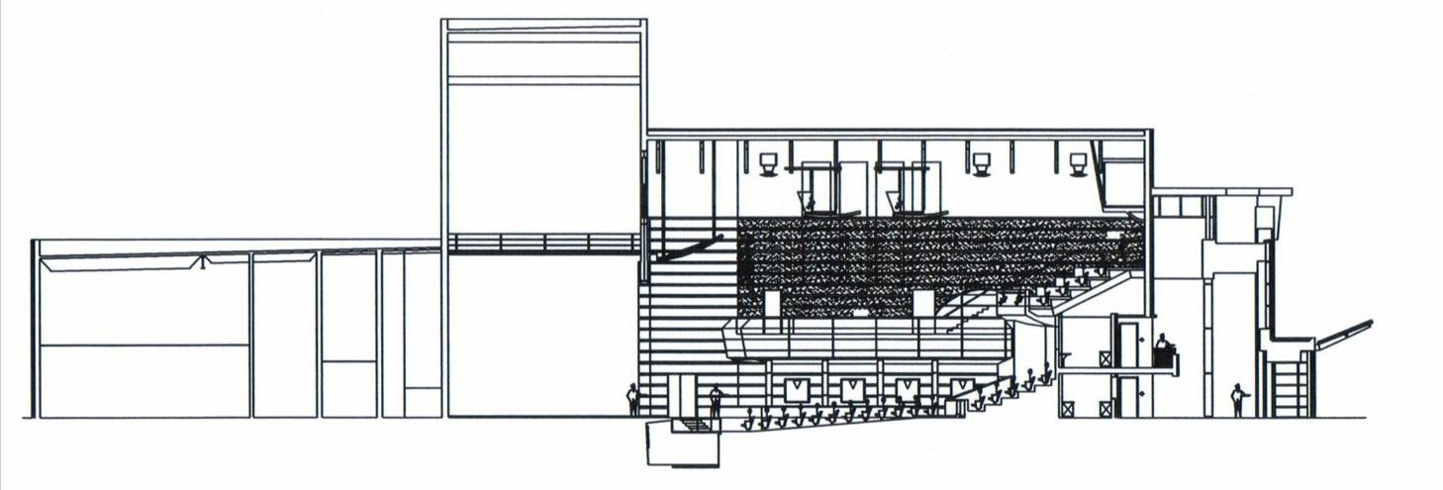
The filler can be set at 3 levels: Orchestra level, House level or Stage level.

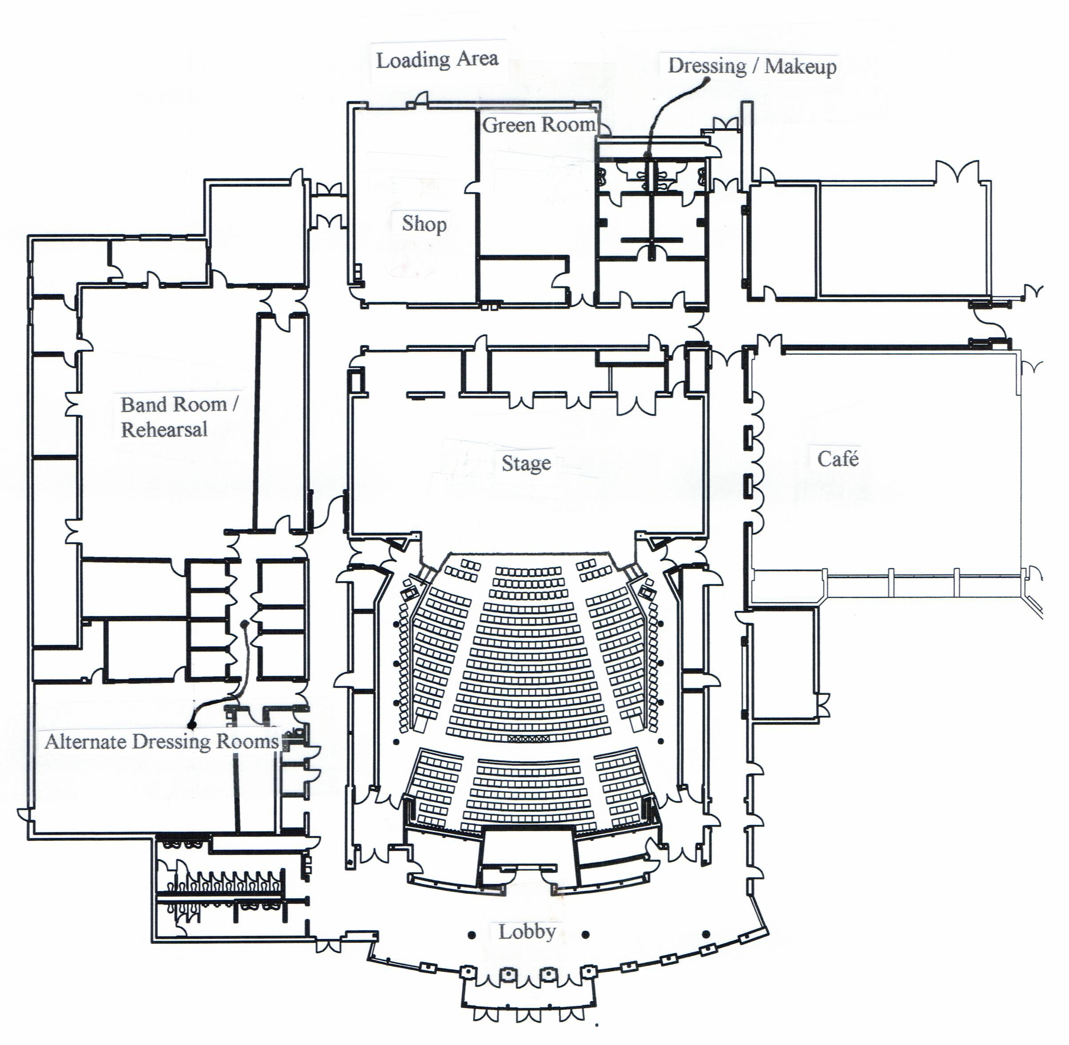

Stage Dimensions
Proscenium
Width |  | 55’
Height |  | 24’
Thickness |  | 2’
Stage Width
SL wall to SR locking rail |  | 86' 8"
Offstage Width
SR (prosc. to locking rail) |  | 17’ 4"
SL (prosc. to SL wall) |  | 17' 4"
Stage Width
SR (center line to SR locking rail) |  | 41' 10"
SL (center line to SL wall) |  | 44' 10"
Stage Depth
DS edge of apron to back wall (US) |  | 40' 4"
DS edge of Pit (at stage level) to back wall |  | 48' 4"
US edge of prosc. to back wall |  | 34' 4"
House curtain to back wall |  | 33’ 4”
House curtain to DS edge of apron |  | 4'
House curtain to DS edge of pit (at stage level) |  | 12' 4"

Misc.
House Curtain
Operates as guillotine from SR locking rail or as traveler from SL deck

Motorized projection screen located in front of proscenium

Wardrobe
Location: No designated area
Access: Not applicable
Facilities: No laundry facility on-site

Dressing Rooms
One Chorus Room with separate male/female restrooms with showers
Located USL on stage level; 30+ person capacity.
Other rooms are available for use as dressing rooms, please speak to the Facility Director about availability

Storage and Rehearsal Areas
Storage Space: None
Rehearsal Space: Various spaces available upon request.

Appendix A: Terminology

Below is a list of terms and their definitions that are commonly used in the theatre world. Although the list is lengthy, there are still many more that could be included. The purpose of this section is to help you become familiar with the lingo used in theatre to help prepare you for Stage Crew membership.

BACKSTAGE The part of the stage and theatre which is out of the sight of the audience. The service areas of the theatre.

BARNDOORS A rotatable attachment consisting of two or four metal flaps (hinged) which is fixed to the front of a lantern to cut off the beam in a particular direction(s).
Certain lanterns use SHUTTERS to achieve a greater degree of control and accuracy.

BELTPACK Part of the communication system in a theatre, the Belt pack contains the controls and circuitry to drive the HEADSET worn by crew members. Each belt pack connects into the headset ring and back to a PSU (Power Supply Unit) which is powered from the mains.

BLACKOUT / BO / B.O. 1) Complete absence of stage lighting. Blue working lights backstage should remain on and are not usually under the control of the board, except during a Dead Blackout (DBO), when there is no onstage light. Exit signs and other emergency lighting must remain on at all times.
2) The act of turning off (or fading out) stage lighting (e.g. 'this is where we go to blackout')

BOARD The main control for the stage lighting and sound. The lighting and sound operator for a show is said to be 'on the board', and is usually known as the 'board op'.

CATWALK An access walkway to equipment. CPAC has two catwalks above the house.

CENTER LINE Imaginary line running down the stage through the exact center of the proscenium opening. Marked as CL on stage plans. Normally marked on the stage floor and used as a reference when marking out or assembling a set.

COUNTERWEIGHT A standard weight (10 or 20lb.) used in a counterweight flying system.

COUNTERWEIGHT SYSTEM Method of flying scenery which uses a cradle containing weights to counterbalance the weight of flown scenery.

CUE 1) The command given to technical crew members to carry out a particular operation. Ex. Fly Cue or Sound Cue. Normally given by stage management, but may be taken directly from the action (i.e. a Visual Cue).
2) Any signal (spoken line, action or count) that indicates another action should follow (i.e. the actors' cue to enter is when the Maid says 'I hear someone coming! Quick - Hide!')

DEPARTMENTS Organizational divisions of staging personnel based on specialist functions – e.g. stage, electrics, props, sound, wardrobe, etc.
DESIGNER The person responsible for conceiving the visual environment of a production and supervising the execution of this concept. Separate designers may be employed for scenery, costumes and lighting.

DIMMER Electrical or electronic device which controls the amount of electricity passed to a lantern, and therefore the intensity of the lamp.

DOWNSTAGE 1) The part of the stage nearest to the audience (the lowest part of a raked stage). [See Diagram]
2) A movement towards the audience (in a proscenium theatre).

FLAT A lightweight timber frame covered with scenic canvas, muslin, or light wood such as lauan. Most theatres have a range of stock flats made to a standard size, and re-used many times.
A Rail is a horizontal batten within a flat.
A Stile is a side or vertical piece within a flat.
A Sill is the bottom rail of a flat.

FRONT OF HOUSE (FOH) 1) Every part of the theatre in front of the proscenium arch. Includes foyer areas open to the general public.
2) All lanterns which are on the audience side of the proscenium and are focused towards the stage.
The backstage areas of the theatre are known as Rear of House (ROH).

GAFFE TAPE Ubiquitous sticky cloth tape. Used for temporarily securing almost anything. Should not be used on coiled cables or equipment. Originally known as Gaffer's Tape, from the Gaffer (Master Electrician) on a film set.

GRID 1) The support structure close to the top of the fly tower on which the pulleys of the flying system are supported. Constructed from metal or wooden beams.
2) Arrangement of scaffolding from which lanterns are hung in a performance space with no flying facilities. Grid is short for GRIDIRON.

HEADSET 1) General term for theatre communication equipment.
2) A headphone and microphone combination used in such communications systems with a belt pack.

HOUSE The auditorium and its audience.

LAMP A light bulb is used in domestic situations (i.e. in the home). In the industry, we only use LAMPS. As the saying goes, 'Bulbs are what you put in the ground'. Example usage: 'The lamp in the DSC fresnel has blown'.

LOAD-IN Moving an entire production into a venue. The process of moving set, props and other hardware into a theatre prior to the rehearsal/event.

LOAD-OUT Moving an entire production out of the venue. Usually proceeded by the strike.

PRESET Anything that is positioned in advance of its being required – such as props placed on the set before the performance; or a scene set behind a front cloth, to be revealed when the cloth is flown.

PROPS (Properties) Furnishings, set dressings, and all items large and small which cannot be classified as scenery, electrics or wardrobe. Props handled by actors are known as hand props, props which are kept in an actor’s costume are known as personal props.

PROSCENIUM ARCH The division between audience and stage in the traditional form of theatre where the audience sits in a single block facing the stage. The proscenium takes many forms from a definite arch, not unlike a picture frame, to an unstressed termination of auditorium walls and ceiling.

SPIKE 1) (vb.) To mark the position of an item of set/furniture on stage.
2) (n.) A mark on stage (e.g. 'put the chair on the spike')
Spike Tape is normally thin gaffe tape, although other weaker tape (e.g. masking tape) is used on precious floors. Sometimes, any securing of cable etc. to floor is known as 'Spiking'. Where precision is required during blackouts, GLOW TAPE is often used to spike positions.

STAGEHAND Member of the Stage staff who is responsible for moving props and/or scenery during the show, and for ensuring that items under their responsibility are working correctly and properly maintained.

STAGEHOUSE The stage floor and all the space above and below it from basement to grid.

STAGE LEFT / RIGHT Left/ Right as seen from the Actor's point of view on stage. (i.e. Stage Left is the right side of the stage when looking from the auditorium).

STAND BY The warning that a cue is imminent; in a state of readiness to carry out an action on cue.

STRIKE To disassemble a stage set ('strike the set'), to remove props from the stage. (e.g. 'how many crew do you need for the strike', 'Strike the armchair after scene 1' etc.)

SUBMASTER Fader on a lighting desk which can have a lighting state recorded onto it for additional control, or to use when manually mixing lighting states for music concerts or one-off events. Lighting boards normally have a series of submasters (12 or 24 are common) which can have states, cues or effects loaded onto them.

TECHNICAL DIRECTOR Often shortened to 'TD' the exact role of the Technical Director changes according to the size of the theatre company, and also according to your location in the world.
In the US, the TD co-ordinates all technical aspects of the production, from organizing crew calls to ensuring equipment is ordered, to liaising with the designers and sometimes adapting a design to fit the venue.

TECHNICAL REHEARSAL Usually the first time the show is rehearsed in the venue, with lighting, scenery and sound. Costumes are sometimes used where they may cause technical problems (e.g. quick changes). Often a very lengthy process. Often abbreviated to the Tech.
A DRY TECH is without actors to rehearse the integration of lighting, scenic changes etc. It follows that a WET TECH is a full technical rehearsal with actors and all technical elements, although this term isn't used as often as DRY TECH.
A PAPER TECH is a session without the set or actors when the technical and design team talk through the show ensuring everything's going to work as planned. Stage Managers can use this session to ensure all is written correctly in the Prompt Book.
TIE LINE 1) A sound connection between two patch panels in different parts of the building. For example, there are tie lines between front of house mixing position and the stage to reduce the need for additional cables through the auditorium. 2) Thin black rope used to for various needs around the theatre (tied around cables and other chords).
UPSTAGE The part of the stage furthest from the audience.
Stage Directions:

Upstage Upstage Upstage
Right Center Left

Center CENTER Center
Right Left

Downstage Downstage Downstage
Right Center Left

Orchestra Pit
or Apron

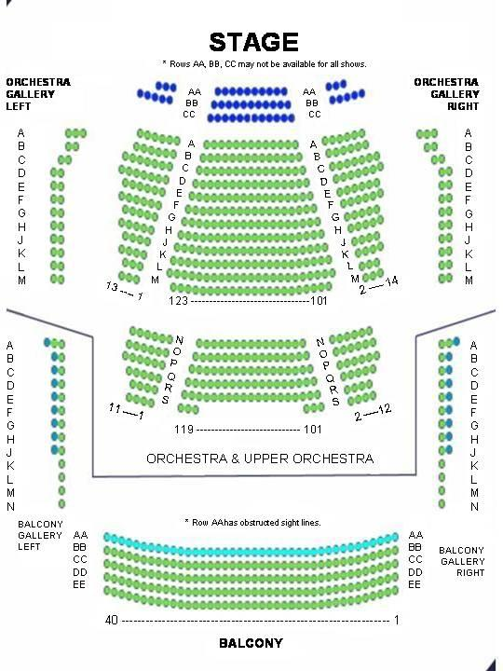
Appendix B: Seating
Appendix C: REFERENCE PAGE

n.d. Student t.
"A Source Four ERS with Major Parts Labeled." October 2006. Picture.
Parish, Amy J. "Stage Crew Employee Handbook ." 2008-09.
"Sound Systems." n.d. Student Technical Theatre Handbook . Document. 6 September 2016.
Systems, Vincent Lighting. "A Crash Course in Lighting." 2016. Vincent Lighting Systems. Document. 6 September 2016.

Useful Links:
High School Tech Stage and Design Technology
http://www.hstech.org/index.php

Backstage Technical Services
http://people.bath.ac.uk/su2bc/cgi/btshome.pl

Apollo Design Technology
http://www.internetapollo.com/
http://www.theatrecrafts.com

Parent/Guardian Permission Form

Warning. Parent and student should note that the nature of technical theatre can be very physical and often dangerous. It may involve working with power tools, handling high output electrical equipment and/or climbing tall ladders. It is imperative that the stage crew member is able to follow directions explicitly and has the ability to communicate with peers. The stage crew member must be able to work as a member of a highly complex team. The stage crew member will be working with tools/equipment that have the capacity to seriously injure. Therefore, while working backstage or in the scene shop, the stage crew member must be highly aware of what is going on around them. We have read the above information and are aware of the potential danger involved with Stage Crew participation. _______________________________ has my permission to (printed student name) participate in the activities of the CPAC Stage Crew.

___________________________________________________
Parent/Guardian Signature

___________________________________________________
Printed parent/guardian name

___________________________________________________
Date

E M E R G E N C Y / H E A L T H F O R M
Charlotte High School
STUDENT NAME: _________________________________________DOB____________________
GRADE: _______________ SCHOOL: ___________________________________________
SAFETY RELEASE/ PERMISSION: I ______________________________________________ am enrolling my son/daughter in the CPAC Stage Crew Program. I understand that if enrolled in tech classes, he/she may be working with power tools and electrical equipment and may be required to climb ladders or work on high grids. I further understand that he/she will be supervised by a Charlotte Public Schools faculty or staff member while engaging in any technical theater work related to official stage crew or drama activities. Acting students may be involved in exercises and physical activities, and will also be supervised by a Charlotte Public Schools faculty or staff member. I fully understand that there is an inherent risk involved in participating, and hereby release the Charlotte Performing Arts Center, Charlotte Public Schools, and all staff and personnel from liability.
PARENT SIGNATURE:_____________________________________________________DATE:_____________________
HOME
ADDRESS:________________________________________CITY:____________________ZIP CODE:__________

PARENT/FAMILY EMAIL:_________________________________STUDENT EMAIL____________________________

PARENT WORK/CELL #(______)________________EVENING #(_____)_________________NAME________________

PARENT WORK/CELL #(______)________________EVENING #(_____)_________________NAME________________

CHILD’S PHYSICIAN:______________________________ PHYSICIAN’S PHONE:(______)______________________

LIST ANY PHYSICAL CONDITIONS/ALLERGIES WHICH MIGHT AFFECT YOUR CHILD’S INVOLVEMENT IN THEATRE:
________________________________________________________________________________________

MAY BE GIVEN: TYLENOL____ ASPIRIN____ IBUPROFEN____ NONE _____

USE EMERGENCY HOSPITAL SERVICE? YES_____ NO_____

SHOULD MY CHILD NEED EMERGENCY MEDICAL ATTENTION AND YOU ARE UNABLE TO CONTACT ME IMMEDIATELY, PLEASE CALL:_____________________________ AT (_____) ______________________

IN THE EVENT THAT YOU ARE UNABLE TO COME FOR YOUR CHILD WITHIN THE FIRST FEW HOURS AFTER A MAJOR DISASTER, YOUR CHILD MAY BE RELEASED TO AN ADULT FAMILIAR TO HIM OR HER, AT THE DISCRETION OF CHARLOTTE PUBLIC SCHOOLS. YES_____ NO _____

CREW CALL TIMES - SEUSSICAL

LIST ANY CONFLICTS
Friday, Oct. 25 – Dry Tech
Call Time 2:45 – 4:30pm ___________________________________________________

Saturday, Oct. 26
Call Time 9am – TBD ___________________________________________________

Monday, Oct. 28
Call Time 2:45 – 5:30pm ___________________________________________________

Monday, Oct. 28
Call Time 2:45 – 5:30pm ___________________________________________________

Tuesday, Oct. 29
Call Time 2:45 – 8:00pm ___________________________________________________

Wednesday, Oct. 30
Call Time 2:45 – 8:00pm ___________________________________________________

Thursday, Oct. 31
Call Time 12:45 – 4:45pm NO CONFLICTS ACCEPTED

Friday, Nov. 1
Call Time 5:30 – Approx. 9:30pm NO CONFLICTS ACCEPTED

Saturday, Nov. 2
Call Time 6pm – Approx. 9:30pm NO CONFLICTS ACCEPTED

Sunday, Nov. 3
Call Time 2pm – End of Strike NO CONFLICTS ACCEPTED

I understand that no conflicts may be added after October 1st. I understand that the number and nature of my conflicts may affect crew positions for the show. Failure to list major conflicts in advance OR scheduled absences may result in immediate dismissal from the show.

STUDENT SIGNATURE ___________________________________________________

DATE ___________________________________________________

PARENT SIGNATURE ___________________________________________________

DATE ___________________________________________________

